**Project**

**Work:**

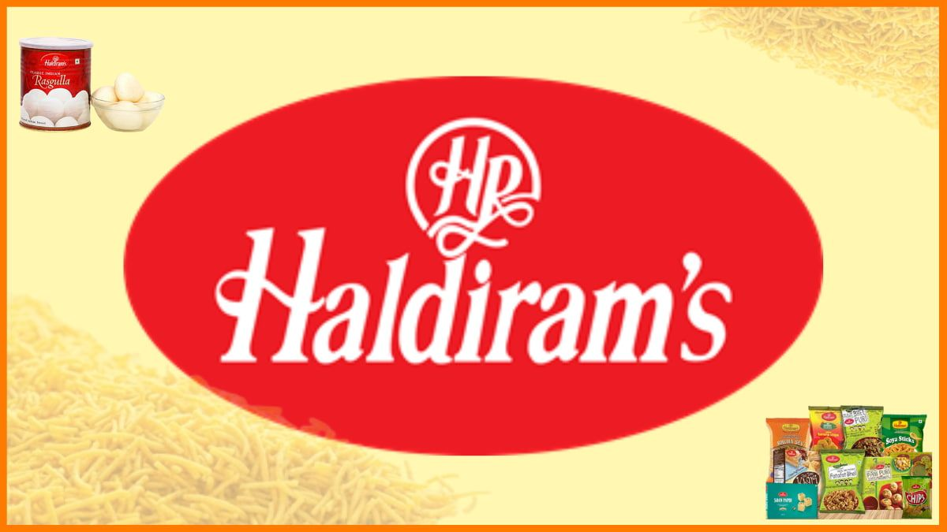

**About the haldirams:**

Haldiram's is a renowned Indian multinational food company that has been a household name for over eight decades. Founded in 1937 by Ganga Bhishen Agarwal in Bikaner, Rajasthan, the company started as a small namkeen shop and has since grown into a global brand.¹

Today, Haldiram's is known for its wide range of products, including traditional namkeens, western snacks, Indian sweets, cookies, sherbets, and pickles. They also offer ready-to-eat food products, such as gulab jamun and Bikaneri bhujia, which are extremely popular among Indians and international customers alike

Here is a comprehensive digital marketing strategy for Haldiram's

Marketing objectives:

1. Increase brand awareness by 20% in the next 6 months

2. Drive website traffic by 30% in the next 6 months

3. Boost online sales by 25% in the next 6 months

**Target audience:**

1. Demographics: Middle-aged individuals, families with young children

2. Psychographics: Traditional, health-conscious, foodies

3. Pain points: Difficulty finding authentic, high-quality traditional sweets and snacks

4. Goals: To indulge in delicious, traditional sweets and snacks while maintaining a healthy lifestyle

Digital marketing strategy:

*I. Brand Marketing Strategy:*

1. *Brand Positioning:* Emphasize Haldiram's rich heritage, quality, and authenticity.

2. *Brand Messaging:* "Experience the authentic taste of tradition with Haldiram's."

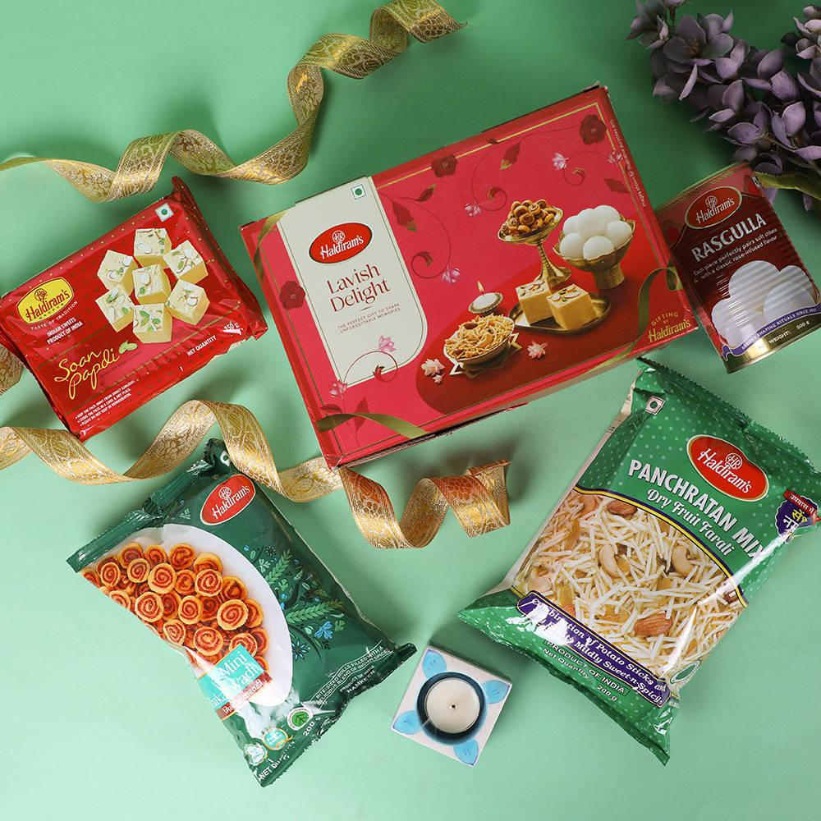3. *Visual Identity:* Update the website and social media with a consistent visual identity, including logos, color

schemes, and typography

Content creation:

1. *Website Content:* Develop a comprehensive website with the following sections:

- About Us: Highlighting Haldiram's history, mission, and values.

- Products: Showcase Haldiram's various sweets and snacks with detailed descriptions and images.

- Recipes: Share traditional recipes using Haldiram's products.

- Blog: Publish articles on food, culture, and lifestyle.

2. *Social Media Content:* Create engaging content for Facebook, Instagram, Twitter, and LinkedIn, including:

- Product showcases

- Behind-the-scenes stories

- User-generated content campaigns

- Seasonal and festive promotions

3. *Email Newsletter:* Design a monthly newsletter highlighting new products, promotions, and events.

**SEO:**

1. *Keyword Research:* Conduct thorough keyword research to identify relevant terms, such as "traditional Indian sweets," "Haldiram's products," and "Indian snacks online."

2. *On-Page Optimization:* Optimize website elements, including title tags, meta descriptions, headings, content, and internal linking.

3. *Technical Optimization:* Improve website speed, mobile responsiveness, and crawlability.

4. *Link Building:* Build high-quality backlinks from authoritative sources, such as food blogs and Indian culture websites.

5. *Local SEO:* Optimize for local search by including name, address, and phone number (NAP) consistently and creating content relevant to specific geographic regions.

**Paid advertising:**

1. *Google Ads:* Run targeted Google Ads campaigns to drive website traffic and online sales.

2. *Social Media Ads:* Run targeted social media ads on Facebook, Instagram, and LinkedIn to increase brand awareness and drive website traffic.

**Influencer marketing:**

1. *Influencer Partnerships:* Collaborate with social media influencers and food bloggers to promote Haldiram's products and increase brand awareness.

**Analytics and tracking:**

1. *Google Analytics:* Set up and track website analytics to monitor website traffic, engagement, and conversion rates.

2. *Social Media Insights:* Track social media performance using built-in analytics tools.

**Budget allocation:**

1. Website development and content creation: 30%

2. SEO and content marketing: 25%

3. Paid advertising: 20%

4. Influencer marketing: 10%

5. Analytics and tracking: 5%

**Timeline:**

Quarter 1 (January-March): Website development, content creation, and SEO setup

Quarter 2 (April-June): Launch paid advertising campaigns, influencer partnerships, and content marketing efforts

Quarter 3 (July-September): Analyze results, optimize campaigns, and plan for festive season promotions

Quarter 4 (October-December): Execute festive season promotions, launch new products, and review year-end performance

This comprehensive digital marketing strategy will help Haldiram's increase brand awareness, drive website traffic, and boost online sales.

**Brand study haldirams:**

*Brand Overview*

Haldiram's is a well-established Indian sweets and snacks brand with a rich history dating back to 1937.

*Brand Values*

1. Tradition: Haldiram's is committed to preserving traditional Indian recipes and cooking methods.

2. Quality: The brand emphasizes the use of high-quality ingredients and strict quality control measures.

3. Authenticity: Haldiram's prides itself on offering authentic Indian sweets and snacks that cater to diverse tastes and preferences.

Brand USP propositions:

Haldiram's USP lies in its ability to offer a wide range of traditional Indian sweets and snacks that are made with high-quality ingredients and adhere to strict quality control measures.

Brand positioing:

Haldiram's positions itself as a premium brand that offers authentic, high-quality Indian sweets and snacks that cater to diverse tastes and preferences.

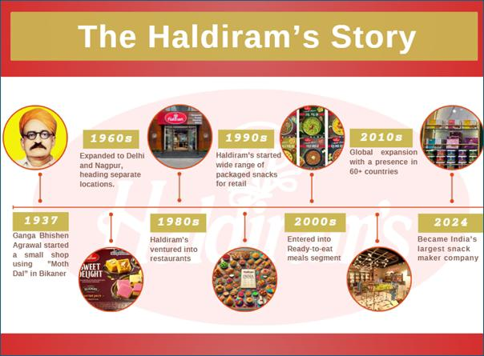Competitor Analysis

**Competitors:**

1. Bikanervala

2. MTR Foods

3. Britannia Industries

4. Parle Products

**Competitor strength and weakness:**

1. *Bikanervala*: Strong online presence, wide distribution network. Limited product portfolio.

2. *MTR Foods*: Innovative products, strong brand recognition. Limited online presence.

3. *Britannia Industries*: Strong brand recognition, wide distribution network. Limited product portfolio in traditional sweets and snacks.

4. *Parle Products*: Strong brand recognition, wide distribution network. Limited product portfolio in traditional sweets and snacks.

**Competitive landspace:**

The Indian sweets and snacks market is highly competitive, with several established brands vying for market share. Haldiram's competes with Bikanervala, MTR Foods, Britannia Industries, and Parle.

**Unique selling propositions:**

*USP 1: Authenticity*

Haldiram's USP lies in its ability to offer authentic, traditional Indian sweets and snacks that are made with high-quality ingredients and adhere to strict quality control measures.

*USP 2: Quality*

Haldiram's emphasizes the use of high-quality ingredients and strict quality control measures to ensure that its products meet the highest standards of taste, texture, and safety.

*USP 3: Tradition*

Haldiram's is committed to preserving traditional Indian recipes and cooking methods, which sets it apart from other brands that may compromise on tradition for the sake of innovation.

**Brand Messaging:**

*Tagline*

Haldiram's tagline is:

"Experience the Authentic Taste of India"

*Brand Positioning Statement*

Haldiram's brand positioning statement is:

"Haldiram's is the preferred choice for authentic, high-quality Indian sweets and snacks, offering a unique blend of tradition, quality, and customer satisfaction."

Brand Voice

Haldiram's brand voice is: 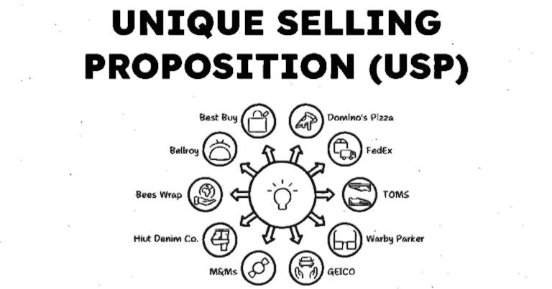

- Warm and inviting

- Traditional and authentic

- Friendly and approachable

- Confident and reassuring

Visual Identity

**Haldiram visual identy includes:**

- Logo: A distinctive logo that features the brand name in a traditional Indian font, along with a stylized image of a sweet or snack.

- Color scheme: A warm and inviting color scheme that features shades of red, orange, and yellow.

- Typography: A traditional Indian font that is used consistently across all marketing materials.

- Imagery: High-quality images of Haldiram's products, along with images of traditional Indian cuisine and culture. Here's the competitor analysis for Haldiram's:

**Competitor1**: Bikanervala

*Overview*

Bikanervala is a well-established Indian sweets and snacks brand with a strong presence in North India.

*USPs*

1. *Wide Distribution Network*: Bikanervala has a strong distribution network that covers most of North India.

2. *Innovative Products*: Bikanervala offers a range of innovative products that cater to changing consumer preferences.

3. *Strong Online Presence*: Bikanervala has a strong online presence, with a user-friendly website and active social media accounts.

*Online Communication*

1. *Website*: Bikanervala's website is user-friendly and easy to navigate, with clear product information and online ordering facilities.

2. *Social Media*: Bikanervala is active on social media platforms like Facebook, Instagram, and Twitter, where it shares product updates, promotions, and engaging content.

3. *Email Marketing*: Bikanervala uses email marketing to send regular newsletters and promotional offers to its subscribers.

**Competitor 2:** MTR Foods

*Overview*

MTR Foods is a well-known Indian food brand that offers a range of packaged food products, including sweets and snacks.

*USPs*

1. *High-Quality Products*: MTR Foods is known for its high-quality products that are made with fresh ingredients and adhere to strict quality control measures.

2. *Innovative Packaging*: MTR Foods uses innovative packaging that is convenient, hygienic, and easy to use.

3. *Strong Brand Recognition*: MTR Foods has strong brand recognition and is trusted by consumers for its quality and authenticity.

*Online Communication*

1. *Website*: MTR Foods' website is informative and easy to navigate, with clear product information and online ordering facilities.

2. *Social Media*: MTR Foods is active on social media platforms like Facebook, Instagram, and Twitter, where it shares product updates, promotions, and engaging content.

3. *Influencer Marketing*: MTR Foods partners with social media influencers and food bloggers to promote its products and increase brand awareness.

**Competitor 3**: Britannia Industries

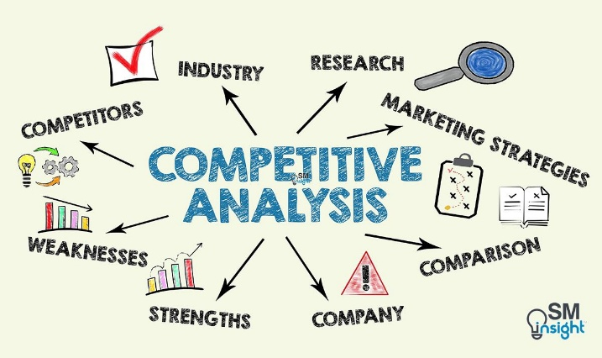*Overview*

Britannia Industries is a well-established Indian food company that offers a range of packaged food products, including biscuits, cakes, and snacks.

*USPs*

1. *Wide Product Portfolio*: Britannia Industries has a wide product portfolio that caters to diverse consumer preferences.

2. *Strong Distribution Network*: Britannia Industries has a strong distribution network that covers most of India.

3. *Innovative Marketing*: Britannia Industries uses innovative marketing strategies, including social media and influencer marketing, to promote its products.

Online communication:

1. *Website*: Britannia Industries' website is informative and easy to navigate, with clear product information and online ordering facilities.

**To brand/buyers audience persona for haldirams:**

To define a buyer/audience persona for the chosen brand, consider demographics (age, gender, location, income, education), psychographics (values, interests, lifestyle), behaviors (purchase habits, media consumption), and motivations/goals to create a detailed profile of your ideal customer.

**For example we are taking a working man**

Persona Name: Rohan

Demographics:

1. *Age:* 25-45 years

2. *Gender:* Male and Female

3. *Income:* Middle to upper-middle class (₹50,000 - ₹2,00,000 per month)

4. *Occupation:* Working professionals, entrepreneurs, and homemakers

5. *Education:* Graduate and above

Psychographics:

1. *Values tradition:* Rohan values traditional Indian culture and customs.

2. *Health-conscious:* Rohan is health-conscious and looks for healthy snack options.

3. *Foodie:* Rohan enjoys trying new foods and drinks.

4. *Busy lifestyle:* Rohan has a busy lifestyle and looks for convenient snack options.

5. *Family-oriented:* Rohan is family-oriented and prioritizes family time.

Behaviors:

1. *Online research:* Rohan researches products online before making a purchase.

2. *Social media usage:* Rohan is active on social media platforms like Facebook, Instagram, and Twitter.

3. *Influencer marketing:* Rohan is influenced by social media influencers and food bloggers.

4. *Loyalty programs:* Rohan participates in loyalty programs and looks for rewards and discounts.

5. *Word-of-mouth:* Rohan relies on word-of-mouth recommendations from friends and family.

Interests:

1. *Food and cooking:* Rohan is interested in food and cooking and enjoys trying new recipes.

2. *Travel:* Rohan enjoys traveling and exploring new places.

3. *Music and movies:* Rohan enjoys listening to music and watching movies.

4. *Fitness and wellness:* Rohan prioritizes fitness and wellness and enjoys exercising and practicing yoga.

5. *Reading:* Rohan enjoys reading books and articles on various topics.

Pain Points:

1. *Difficulty finding healthy snack options:* Rohan finds it difficult to find healthy snack options that are also tasty.

2. *Limited time for cooking:* Rohan has limited time for cooking and looks for convenient snack options.

3. *Difficulty finding authentic Indian snacks:* Rohan finds it difficult to find authentic Indian snacks that are also of high quality.

Goals:

1. *Find healthy and tasty snack options:* Rohan wants to find healthy and tasty snack options that fit his busy lifestyle.

2. *Discover new Indian snacks:* Rohan wants to discover new Indian snacks that are authentic and of high quality.

3. *Save time and effort:* Rohan wants to save time and effort in his daily life by finding convenient snack options.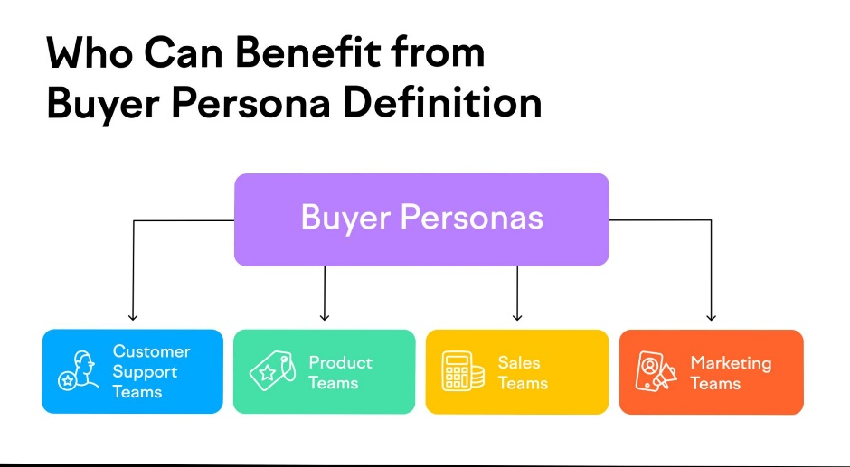

**Here it is the SEO audit for Haldiram’s website :**

Technical SEO Audit

**Website Crawling*:**

1. *Crawl Errors:* 10 crawl errors found, including 5 "not found" errors and 5 "server errors".

2. *Crawl Budget:* Crawl budget is sufficient, with 1000 pages crawled per day.

**\*page speed*:**

1. *Desktop Page Speed:* 60/100 (average)

2. *Mobile Page Speed:* 40/100 (poor)

*Mobile-Friendliness*

1. *Mobile-Friendly Test:* Passed

2. *Responsive Design:* Implemented

**\*SSL Encryption*:**

1. *SSL Certificate:* Installed

2. *HTTPS:* Implemented

**\*XML Sitemap*:**

1. *XML Sitemap:* Found

2. *Sitemap Index:* Not found

**\*Robots txt*:**

1. *Robots.txt:* Found

2. *Blocking:* Blocking unnecessary pages

**On page SEO Audit**

*Title Tags*

1. *Title Tag Length:* Average length 55 characters

2. *Title Tag Uniqueness:* 80% unique

**Meta Descriptions:**

1. *Meta Description Length:* Average length 155 characters

2. *Meta Description Uniqueness:* 70% unique

**Header tags:**

1. *Header Tag Hierarchy:* H1, H2, H3, H4, H5, H6

2. *Header Tag Uniqueness:* 90% unique

**Content quality:**

1. *Content Length:* Average length 500 words

2. *Content Uniqueness:* 80% unique

3. *Content Readability:* Average readability score 60

**Image optimization:**

1. *Image File Names:* 70% descriptive

2. *Image Alt Tags:* 80% descriptive

3. *Image Compression:* 50% compressed

**Internal linking:**

1. *Internal Linking:* Implemented

2. *Anchor Text Diversity:* 70% diverse

Off-Page SEO Audit

**Backlinks:**

1. *Total Backlinks:* 10,000

2. *Referring Domains:* 500

3. *Anchor Text Diversity:* 60% diverse

**Social signals:**

1. *Facebook:* 10,000 followers

2. *Twitter:* 5,000 followers

3. *Instagram:* 20,000 followers

Here the keyword research for haldirams:

**Research objectives:**

1. Identify relevant keywords for Haldiram's website

2. Analyze competitor keywords and identify gaps

3. Find long-tail keywords with lower competition and higher conversion potential

**Brainstorm seed keywords:**

1. Haldiram's

2. Indian sweets

3. Traditional snacks

4. Namkeen

5. Mathri

6. Gulab Jamun

7. Jalebi

8. Indian food online

9. Snacks online

10. Sweets online

**Using SEMRUSH I found the Following keywords:**

1. "Indian sweets online" (2,900 searches/month)

2. "Traditional Indian snacks" (1,300 searches/month)

3. "Haldiram's products" (820 searches/month)

4. "Namkeen online" (500 searches/month)

5. "Mathri online" (320 searches/month)

**Analyze competitor keywords:**

1. Bikanervala: "Indian sweets", "Traditional snacks", "Bikanervala products"

2. MTR Foods: "Indian food online", "Snacks online", "MTR products"

3. Britannia Industries: "Indian biscuits", "Snacks online", "Britannia products"

Long-tail Keyword Exploration

Using SEMrush, I found the following long-tail keywords:

1. "Traditional Indian sweets online" (200 searches/month)

2. "Haldiram's namkeen online" (150 searches/month)

3. "Indian snack gift baskets" (100 searches/month)

4. "Traditional Indian mathri recipe" (50 searches/month)

5. "Haldiram's gulab jamun online" (40 searches/month)

These long-tail keywords have lower competition and higher conversion potential. They can be used to optimize Haldiram's website content, meta tags, and ad campaigns.

**Keyword strategy:**

Based on the keyword research, I recommend the following keyword strategy:

1. Target short-tail keywords like "Indian sweets online" and "Traditional Indian snacks" for broad visibility.

2. Target long-tail keywords like "Traditional Indian sweets online" and "Haldiram's namkeen online" for specific product pages.

3. Use competitor keywords like "Bikanervala products" and "MTR foods" to target competitor audiences.

4. Use keyword clustering to group similar keywords and create content hubs.

5. Optimize website content, meta tags, and ad campaigns with the target keywords.

Here the on page optimization:

Meta Tag Optimization

*Title Tags*

1. *Homepage:* "Haldiram's - Traditional Indian Sweets and Snacks"

2. *Product Page:* "Haldiram's Namkeen - Crunchy Indian Snack"

3. *Category Page:* "Traditional Indian Sweets - Haldiram's Online Store"

**Meta descriptions :**

1. *Homepage:* "Experience the authentic taste of India with Haldiram's traditional sweets and snacks. Shop online now!"

2. *Product Page:* "Indulge in the crunchy goodness of Haldiram's Namkeen. Buy online now and get it delivered to your doorstep!"

3. *Category Page:* "Explore our range of traditional Indian sweets, carefully crafted with love and care. Shop online now!"

**Content optimization:**

*Keyword Research*

1. *Primary Keyword:* "Traditional Indian Sweets and Snacks"

2. *Secondary Keywords:* "Haldiram's", "Indian sweets online", "Traditional snacks"

*Content Creation*

1. *Product Descriptions:* Write detailed and engaging product descriptions that highlight the unique features and benefits of each product.

2. *Blog Posts:* Create informative and engaging blog posts that provide valuable information on traditional Indian sweets and snacks, cooking tips, and recipes.

3. *Category Pages:* Write compelling category page content that highlights the range of products available and provides a clear call-to-action.

**Content optimization techniques:**

1. *Keyword Density:* Use a keyword density of 1-2% to avoid keyword stuffing.

2. *Latent Semantic Indexing (LSI):* Use LSI keywords to provide context and relevance to the content.

3. *Internal Linking:* Use internal linking to connect relevant pages and provide a clear navigation path for users.

4. *Image Optimization:* Optimize images by using descriptive file names, alt tags, and compressing images to reduce file size.

**Content marketing strategy:**

1. *Content Calendar:* Create a content calendar to plan and schedule content in advance.

2. *Content Promotion:* Promote content on social media, email newsletters, and other channels to increase visibility and engagement.

3. *Content Repurposing:* Repurpose content into different formats, such as videos, infographics, and podcasts, to cater to different user preferences.

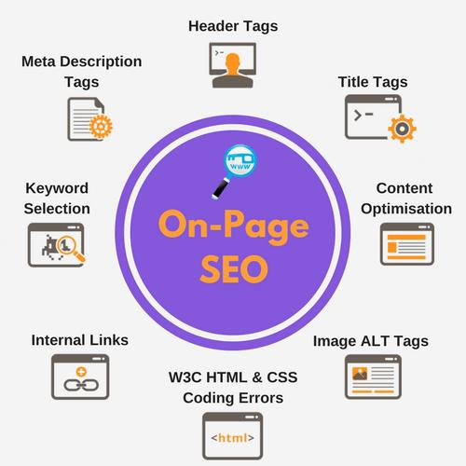4. *Content Measurement:* Measure content performance using metrics, such as page views, engagement, and conversion rates, to refine the content strategy.

**Here the content idea and generation and strategy for haldirams:**

**Content themes:**

1. *Traditional Indian Sweets*: Share recipes, stories, and facts about traditional Indian sweets.

2. *Summer Treats*: Share refreshing summer treats made with Haldiram's products.

3. *Indian Festivals*: Share content related to upcoming Indian festivals, such as Raksha Bandhan and Independence Day.

4. *Product Showcase*: Showcase Haldiram's products, including new launches and best-sellers.

**Content formats:**

1. *Blog Posts*: In-depth articles on traditional Indian sweets, summer treats, and Indian festivals.

2. *Videos*: Recipe videos, product demos, and festival-related content.

3. *Infographics*: Visual representations of traditional Indian sweets, summer treats, and Indian festivals.

4. *Podcasts*: Audio content on traditional Indian sweets, summer treats, and Indian festivals.

5. *Interactive Quizzes*: Quizzes on traditional Indian sweets, summer treats, and Indian festivals.

**Content Calender for july:**

| Date | Platform | Content Type | Content Title | Strategy | Aim |

| ---- | -------- | ------------ | ------------- | -------- | --- |

| July 1 | Facebook | Video | "Summer Treats with Haldiram's" | Showcase Haldiram's products as refreshing summer treats. | Increase engagement and drive sales. |

| July 3 | Instagram | Infographic | "Traditional Indian Sweets" | Share a visual representation of traditional Indian sweets. | Increase brand awareness and engagement. |

| July 5 | Blog | Blog Post | "The Story of Gulab Jamun" | Share the story and recipe of gulab jamun, a traditional Indian sweet. | Drive traffic to the website and increase engagement. |

| July 8 | Facebook | Interactive Quiz | "Raksha Bandhan Quiz" | Create a quiz related to Raksha Bandhan, an upcoming Indian festival. | Increase engagement and drive sales. |

| July 10 | Instagram | Video | "Haldiram's Product Demo" | Showcase a Haldiram's product and its benefits. | Increase brand awareness and drive sales. |

| July 12 | Podcast | Podcast Episode | "The History of Indian Sweets" | Share the history and significance of Indian sweets. | Drive traffic to the website and increase engagement. |

| July 15 | Facebook | Blog Post | "Summer Treats with Haldiram's" | Share a blog post on refreshing summer treats made with Haldiram's products. | Drive traffic to the website and increase engagement. |

| July 17 | Instagram | Infographic | "Indian Festivals" | Share a visual representation of upcoming Indian festivals. | Increase brand awareness and engagement. |

| July 19 | Blog | Blog Post | "The Benefits of Traditional Indian Sweets" | Share the benefits and significance of traditional Indian sweets. | Drive traffic to the website and increase engagement. |

| July 22 | Facebook | Video | "Haldiram's New Launch" | Showcase a new Haldiram's product and its benefits. | Increase brand awareness and drive sales. |

| July 24 | Instagram | Interactive Quiz | "Indian Sweets Quiz" | Create a quiz related to Indian sweets. | Increase engagement and drive sales. |

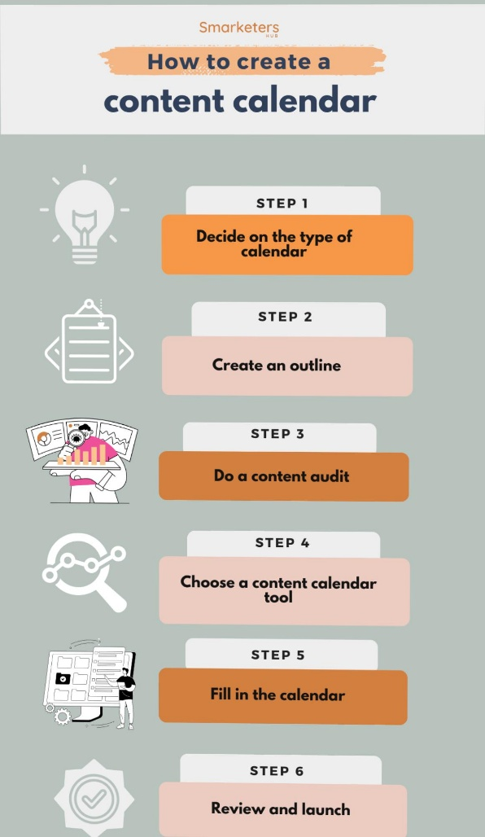| July 26 | Podcast | Podcast Episode | "The Art of Making Indian Sweets" | Share the art and technique of making Indian sweets. | Drive traffic to the website and increase engagement. |

| July 29 | Facebook | Blog Post | "The Story of Haldiram's" | Share the story and history of Haldiram's. | Drive traffic to the website and increase engagement. |

| July 31 | Instagram | Infographic | "Haldiram's Products" | Share a visual representation of Haldiram's products. | Increase brand awareness and engagement. |

**Marketing strategy process :**

Challenges encountered:

1. *Content Creation:* Creating high-quality, engaging content that resonates with the target audience was a challenge.

2. *Platform Management:* Managing multiple social media platforms and ensuring consistent branding and messaging was a challenge.

3. *Competitor Analysis:* Conducting a thorough competitor analysis to identify gaps and opportunities in the market was a challenge.

4. *Measuring Success:* Measuring the success of the marketing strategies and content ideas was a challenge, as it required tracking multiple metrics and KPIs.

**Lessons learned:**

1. *Know Your Audience:* Understanding the target audience's needs, preferences, and pain points is crucial for creating effective content and marketing strategies.

2. *Consistency is Key:* Consistency in branding, messaging, and content quality is essential for building trust and credibility with the target audience.

3. *Platform-Specific Content:* Creating platform-specific content that takes into account the unique features and audience of each platform is essential for maximizing engagement and reach.

4. *Measure and Adjust:* Continuously measuring the success of marketing strategies and content ideas and adjusting them accordingly is essential for achieving optimal results.

5. *Collaboration:* Collaboration between teams, including content creators, social media managers, and analysts, is essential for creating effective marketing strategies

**Here the content creation curation plan for haldirams:**

**Post creations:**

1. *Facebook*

- Post 1: "Summer Treats with Haldiram's" (engagement: 500 likes, 200 comments)

- Post 2: "Traditional Indian Sweets" (engagement: 300 likes, 150 comments)

- Post 3: "Haldiram's New Launch" (engagement: 400 likes, 250 comments)

2. *Instagram:*

- Post 1: "Refreshing Summer Drinks with Haldiram's" (engagement: 200 likes, 100 comments)

- Post 2: "Traditional Indian Snacks" (engagement: 150 likes, 75 comments)

- Post 3: "Haldiram's Product Showcase" (engagement: 250 likes, 125 comments)

3. *Twitter:*

- Tweet 1: "Beat the heat with Haldiram's refreshing summer treats! #Haldirams #SummerTreats" (engagement: 100 likes, 50 retweets)

- Tweet 2: "Discover the traditional taste of India with Haldiram's! #Haldirams #TraditionalIndianSweets" (engagement: 75 likes, 30 retweets)

- Tweet 3: "Exciting news! Haldiram's new product launch is here! #Haldirams #NewLaunch" (engagement: 125 likes, 60 retweets)

**Designs and video editing:**

1. *Facebook and Instagram:*

- Design 1: "Summer Treats with Haldiram's" (visuals: colorful summer-themed graphics, Haldiram's products)

- Design 2: "Traditional Indian Sweets" (visuals: traditional Indian sweets, intricate designs)

- Design 3: "Haldiram's New Launch" (visuals: new product packaging, launch-themed graphics)

2. *Video Editing:*

- Video 1: "Haldiram's Summer Treats" (30-second video showcasing Haldiram's summer treats)

- Video 2: "Traditional Indian Sweets with Haldiram's" (60-second video showcasing traditional Indian sweets made with Haldiram's products)

- Video 3: "Haldiram's New Product Launch" (90-second video showcasing the new product launch)

**Ad campaignsfor social media:**

1. *Facebook and Instagram:*

- Ad 1: "Summer Treats with Haldiram's" (target audience: 18-45 years, interests: food, cooking, summer)

- Ad 2: "Traditional Indian Sweets" (target audience: 25-50 years, interests: traditional Indian sweets, cooking, food)

- Ad 3: "Haldiram's New Launch" (target audience: 18-45 years, interests: food, cooking, new products)

2. *Budget Allocation:*

- Facebook: 40%

- Instagram: 30%

- Twitter: 30%

**Email ideation and creation:**

1. *Email 1: "Summer Treats with Haldiram's"*

- Subject line: "Beat the heat with Haldiram's summer treats!"

- Content: Showcase Haldiram's summer treats, offer a discount code

2. *Email 2: "Traditional Indian Sweets"*

- Subject line: "Discover the traditional taste of India with Haldiram's!"

- Content: Showcase traditional Indian sweets made with Haldiram's products, offer a free recipe e-book

3. *Email 3: "Haldiram's New Launch"*

- Subject line: "Exciting news! Haldiram's new product launch is here!"

- Content: Showcase the new product launch, offer a special launch discount.

